# MEGHNAD SAHA INSTITUTE OF TECHNOLOGY

*Nazirabad, P.O. - Uchhepota, Near URBANA Complex, Anandapur, Kolkata 700 150*

**BACHELOR OF COMPUTER APPLICATION**



LABORATORY NOTE BOOK

MAKAUT ODD SEMESTER 2023

PAPER NAME: COMPUTER NETWORKING LAB

PAPER CODE: BCAC592

STUDENT NAME: RUPAK SARKAR

ROLL NO: 31001221010

REGN. NO.: 213101001210001

YEAR: 3RD

SEMESTER: 5TH

SECTION: BCA

SESSION: 2021-2024



MEGHNAD SAHA INSTITUTE OF TECHNOLOGY

*Nazirabad, P.O. - Uchhepota, Near URBANA Complex, Anandapur, Kolkata 700 150*

## “LIST OF ASSIGNMENT/EXPERIMENT SUBMISSION DETAILS”

|  |  |  |  |  |  |
| --- | --- | --- | --- | --- | --- |
| **SL.**  **NO.** | **ASSIGNMENT / EXPERIMENT NAME** | **DATE OF ASSIGNMENT**  **/ EXPERIMENT DONE** | **DATE OF SUBMISSION** | **CHECKED BY** | **REMARKS**  **(ANY DEVIATION REGARDING SUBMISSION DATES, CONTENT, FORMAT, ETC)** |
| 1. | Configuration of Physical LAN. | 30/09/2023 | 30/09/2023 |  |  |
| 2. | Explain ping, getmac, arp, nslookup, tracert | 30/09/2023 | 30/09/2023 |  |  |
| 3. | Explain netstat, route, ipconfig, ifconfig | 30/09/2023 | 30/09/2023 |  |  |
|  |  |  |  |  |  |
|  |  |  |  |  |  |
|  |  |  |  |  |  |
|  |  |  |  |  |  |
|  |  |  |  |  |  |
|  |  |  |  |  |  |
|  |  |  |  |  |  |
|  |  |  |  |  |  |
|  |  |  |  |  |  |
|  |  |  |  |  |  |
|  |  |  |  |  |  |
|  |  |  |  |  |  |

OBSERVATIONS / COMMENTS ON THE OVERALL PERFORMANCE:

Signature in full with date

Faculty / Technical Assistant

Assignment-2

1. HOW to configure/setup physical LAN – Explain in details.
2. Explain: (a)ping(b) getmac (c) arp (d) nslookup (e) tracert
3. Explain: (a) netstat (b) route (c) ipconfig (d)ifconfig

### **Instructions to set up LAN Network:**

1. **Identify services:** Identify the network services such as printers, disk drives, data, etc. that will be shared among workstations.
2. **Identify devices:** Identify devices such as computers, mobile phones, laptops, etc. with a unique address that will be connected to the network.
3. **Plan connections:** Design the network by laying out cable wires between network devices or by making wireless connections. Wired LAN is set up using Ethernet cables while wireless LAN is set up using Wi-Fi that connects network devices without making any physical connection. A wired LAN network is more secure than a wireless LAN network but it is difficult to relocate.
4. **Select networking device:** Select switch or router with enough ports to connect all workstations within the network. The choice of networking device is based on the requirements of the network.
5. **Configure ports:** Configure WAN ports according to the information provided by ISP (Internet Service Provider). Also, configure LAN ports of cable routers such that there are enough addresses available for all the workstations within the network. A cable router acts as DHCP (Dynamic Host Configuration Server) server that automatically allocates addresses to all the devices connected to the network.
6. **Make connections:** Connect all the devices using wires to configure a LAN network. Standard Ethernet cables are used to connect workstations and servers while Ethernet crossover cable is used to connect the switch to cable routers by connecting the standard port of the switch with router’s LAN port. For wireless LAN, connect all the devices to Wi-Fi with SSID (Service Set Identifier) provided by the router or switch to configure the LAN network.
7. **Test the network:** Test each of the workstation connected to the network and ensure every workstation have access to network services.

* **Ping**

Can verify if a computer can connect over the network to another computer or network device. It can also find out the IP address using the host name.

**Traceroute**

Checks the path (the server hops) that the computer is using to connect to the network.

**Nslookup**

Allows you to query name servers for information about various hosts and domains, or to print a list of the hosts in a domain.

* **Getmac**

Displays the MAC address for each network card in the computer.

### **Ipconfig:**

This command displays all current TCP/IP network configuration values and refreshes Dynamic Host Configuration Protocol (DHCP) and Domain Name System (DNS) settings. This command is mainly used to view the IP addresses on the computers that are configured to obtain their IP address automatically.

The following image shows the sample output of this command.

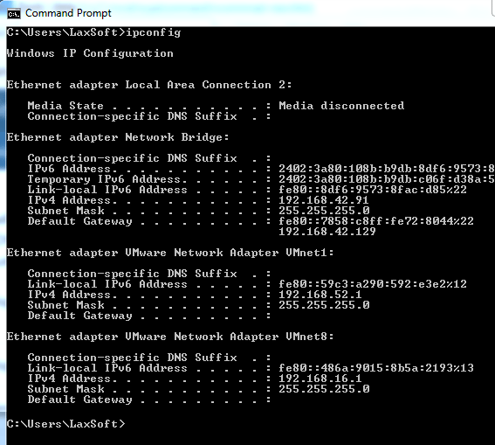

### **Netstat**

This command displays active connections, ports on which the computer is listening, Ethernet statistics, the IP routing table, and IP statistics.

The output of this command is organized in rows and columns. Each row represents a new connection or an entry in the output. It contains four columns. These columns provide the following information about the row.

**Proto**: - This column displays the name of the protocol (TCP or UDP).

**Local Address**: - This column displays the IP address of the local computer and the port number being used. If the port is not yet established, the port number is shown as an asterisk (**\***).

**Foreign Address**: - This column displays the IP address and port number of the remote computer to which the port is connected.

**State**: - This column displays the status of the connection.

The following image shows the sample output of this command.

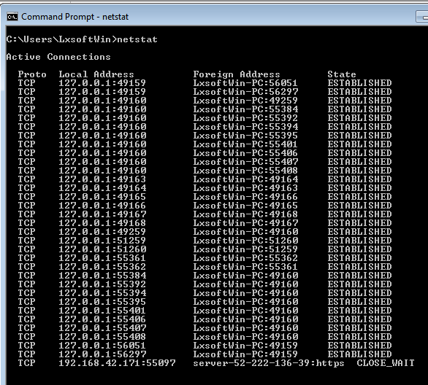

#### **Ifconfig:**

**ifconfig stands for Interface Configuration. This command is the same as ipconfig, and is used to view all the current TCP/IP network configurations values of the computer.**

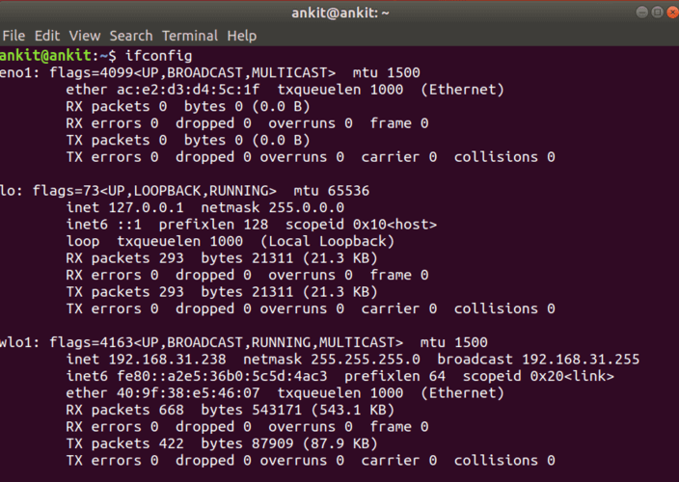

[Route](https://www.freecodecamp.org/news/traceroute-and-ping/" \l ":~:text=Ping%20and%20traceroute%20are%20common,when%20traveling%20to%20its%20destination.)

Route is a command that displays the current routing table for a computer. The routing table is a list of entries that tells the computer how to send data to other computers on the network.